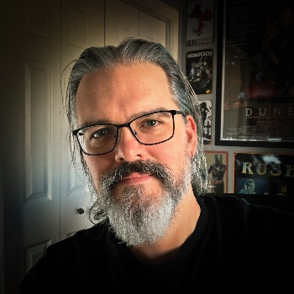

## Skills

## Senior / Lead VFX

## Team player & communicator

## Nuke, AE, Mocha, PS

## Maya, Blender, Resolve

## 2D / 3D compositing

## Motion graphics

## VFX pipeline savvy

## Detail-focused eye

## Lighting & color theory

## Organized & proactive

## Education

Bachelor’s Degree in Visual Effects

Savannah College of Art and Design

2010

## Skills

* Senior Level and Lead
* Java, SQL
* Debugging
* Microsoft Office
* Spreadsheets

567-303-2514

brian.mccann@mccannvfx.com

Pooler, GA, USA

**My Portfolio**

https://www.mccannvfx.com/

**LinkedIn**

https://www.linkedin.com/in/brianpatrickmccann/

**IMBD**

https://www.imdb.com/name/nm7068733/?ref_=ext_shr_lnk



## Contact

Brian McCann

compositor/VFX Artist

## Professional overview

My foundation in fine art and illustration, combined with my visual effects education, fuels my unique approach as a visual effects compositor. Over the past 15 years, I’ve honed my craft in film and digital media, contributing to over 75 films with stunning visuals that elevate storytelling. Collaborating with talented teams on diverse projects, I seamlessly blend creativity with technical expertise. Passionate about pushing creative boundaries, I’m dedicated to mastering emerging technologies and delivering excellence in the ever-evolving VFX industry.

## Work experience

### 2023 – present McCann VFX – Founder/VFX Supervisor/Compositor/VFX Artist

Compositing 2D/3D elements and effects for film and commercials.

Clients: INSP, Visionary FX, Oddmachine, Rohtau, Double Entendre, and Blackwater.

Work: The White Lotus, American Primeval, Mythic Quest, Blue Ridge: The Series, etc.

### 2024 – 2025 Whiskytree - Compositor/VFX Artist

Compositing 2D/3D elements and effects.

Work: TBA

### 2019 – 2023 Crafty Apes – Compositor/VFX Artist

Compositing 2D/3D elements and effects.

Work: Star Trek: SNW, Hillbilly Elegy, The Menu, The Staircase, Legacies, Uglies, etc.

### 2017 – 2018 Method Studios – Compositor/VFX Artist

Compositing 2D/3D elements and effects. Packaged artist scripts for vendors.

Work: Black Panther, Thor: Ragnarok, and The New Mutants.

### 2014 – 2017 Gener8 Digital Media Group – Compositor/VFX Artist

Compositing 2D/3D elements and effects for stereoscopic conversion.

Work: Justice League, Transformers: The Last Knight, Wonder Woman, etc.

### 2012 – 2014 Digital Hyper Studios – Compositor/VFX Artist

Compositing 2D/3D elements and effects for film and commercials.

Work: Suzie’s Hope, Shuffleton’s Barbershop and The Ultimate Life.

### 2010 – 2012 Digital Domain Media Group – Compositor/VFX Artist

Compositing 2D/3D elements and effects for stereoscopic conversion.

Work: Transformers: Dark of the Moon, The Smurfs, The Last Emperor